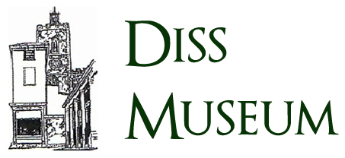

**THE R34 ADVENTURE – INTERACTIVE EXPERIENCE**

Diss Museum are in preparations to host the R34 adventure exhibition, to commemorate the centenary of the first double airborne crossing of the Atlantic Ocean. The exhibition will feature a variety of displays and performances showcasing the history of the R34 and its voyage.

To better engage attendees, we would like to offer an educational interactive experience involving the R34 and its historic mission for the duration of the exhibition 13-14 July 2019.

The application should be developed for mobile platforms and make use of augmented reality through the device camera. All attendees of the exhibition must be able to use the application simultaneously as they move around the venue.

Our intention is to educate children about the events of the airship’s voyage – as such it is essential the final product is thoroughly researched and historically accurate.

To provide better perspective on the events of the voyage the application should showcase a range of items and events from the crossing.

The application must be designed with the exhibition location (Diss Museum) in mind. Locations of all planned performances and installations must be considered so that use of the application does not interfere in the exhibits activity.

The final product and all supporting material must be ready for public release prior to 1st March 2019.

**Audience**

The experience produced should educate primary school-aged children. Content must be age appropriate and sufficient to engage the user for 30 minutes to an hour.

Use of the application must be intuitive so the experience can be shared by the children and their families.

**Technical details**

The application must feature augmented reality. When viewing a valid source through the device camera, the application should display a 3D model on screen which through user interaction will provide accurate information relevant to the object. After ‘discovering’ a model, users should be given the option of either playing a visual effect over the model, being shown an event log relevant to the model, or playing a mini-game themed around the model.

The application should be produced for release on Android and IOS devices and available on marketplaces prior to 1 March 2019.

All necessary AR sources and an advertisement suitable for inclusion within Diss Museum's promotional material must be fully completed for public release and made available to Diss Museum prior to 1 March 2019.

**What is required**

An individual or team eager to learn the history of the R34 and creatively pass the knowledge onto others. The individual(s) will be responsible for the design of the experience, user interaction with the application and augmented reality elements as well as overseeing the public release.

The Museum has members who can aid with any research needs related to the history of the R34.